Myles J Sartor
Matthew Griffin
STAT100-0121
1 November 2023
Extra Credit Problem Set
1a. 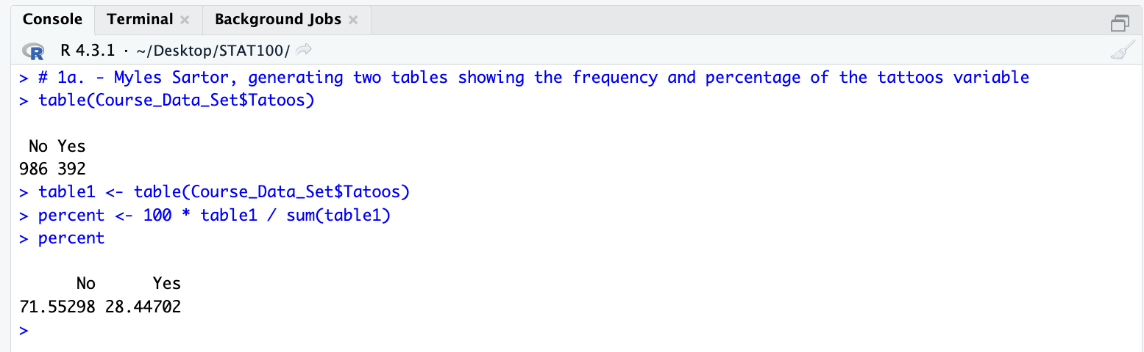
1b. 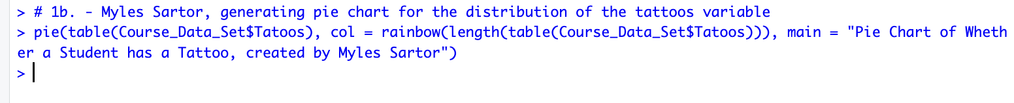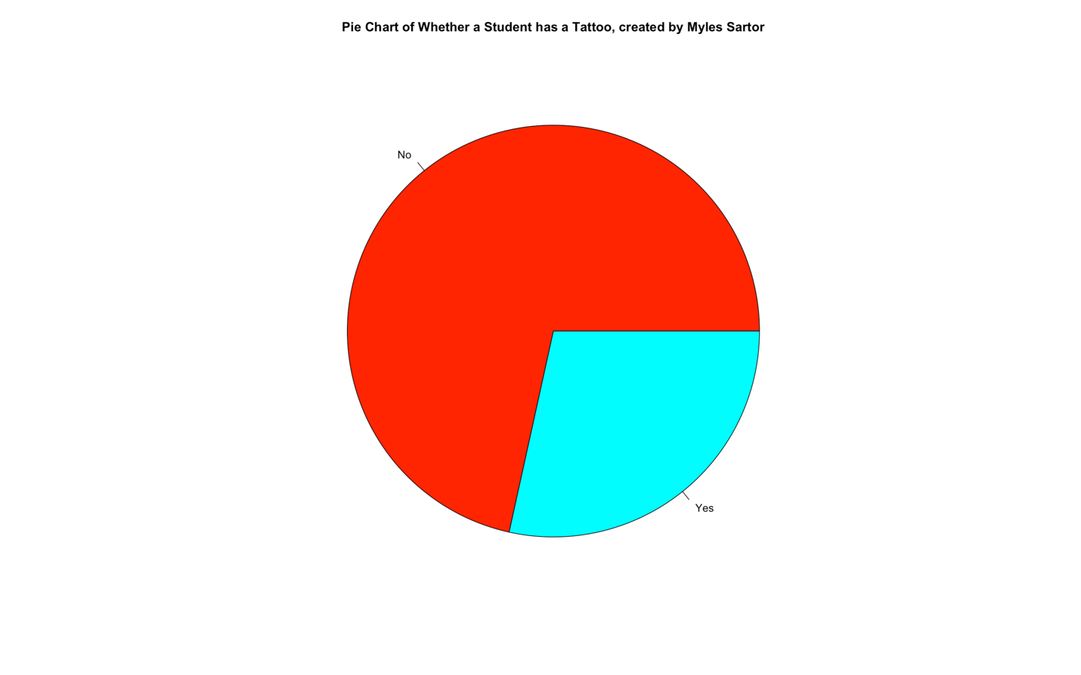
2a.
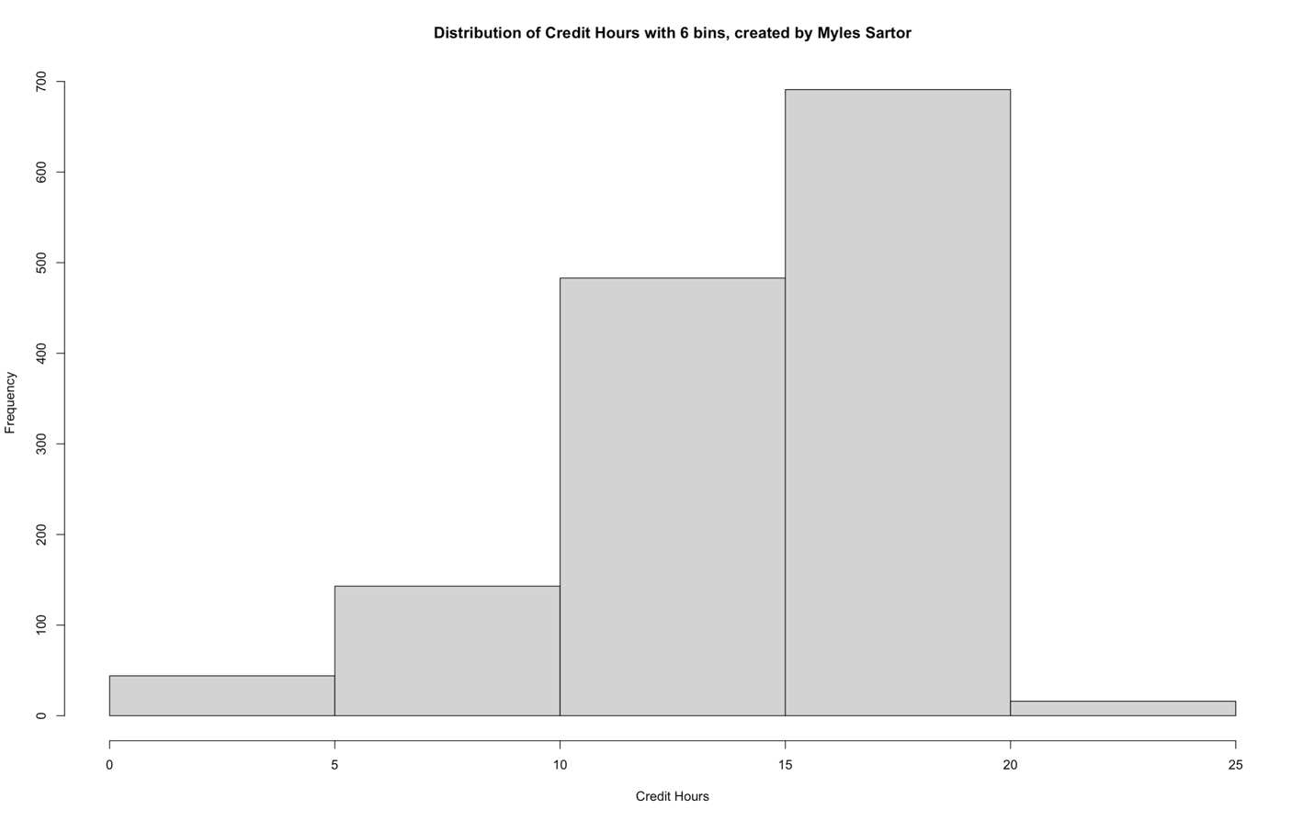
2b. By looking at the histogram, I can conclude that the median number of enrolled credit hours that a student has is between the 15 and 20 interval, since this is the interval that has the 710th and 711th observation in the distribution, which is where the possible values for the median begins. By adding up all the given frequencies together, I got 1420 observations in total, and dividing this even number by 2 gives 710, which gives me the beginning observation that lies in the middle of the data set for the credit hours.
3a.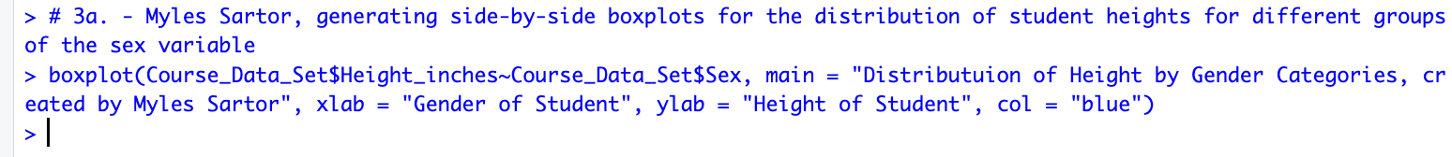
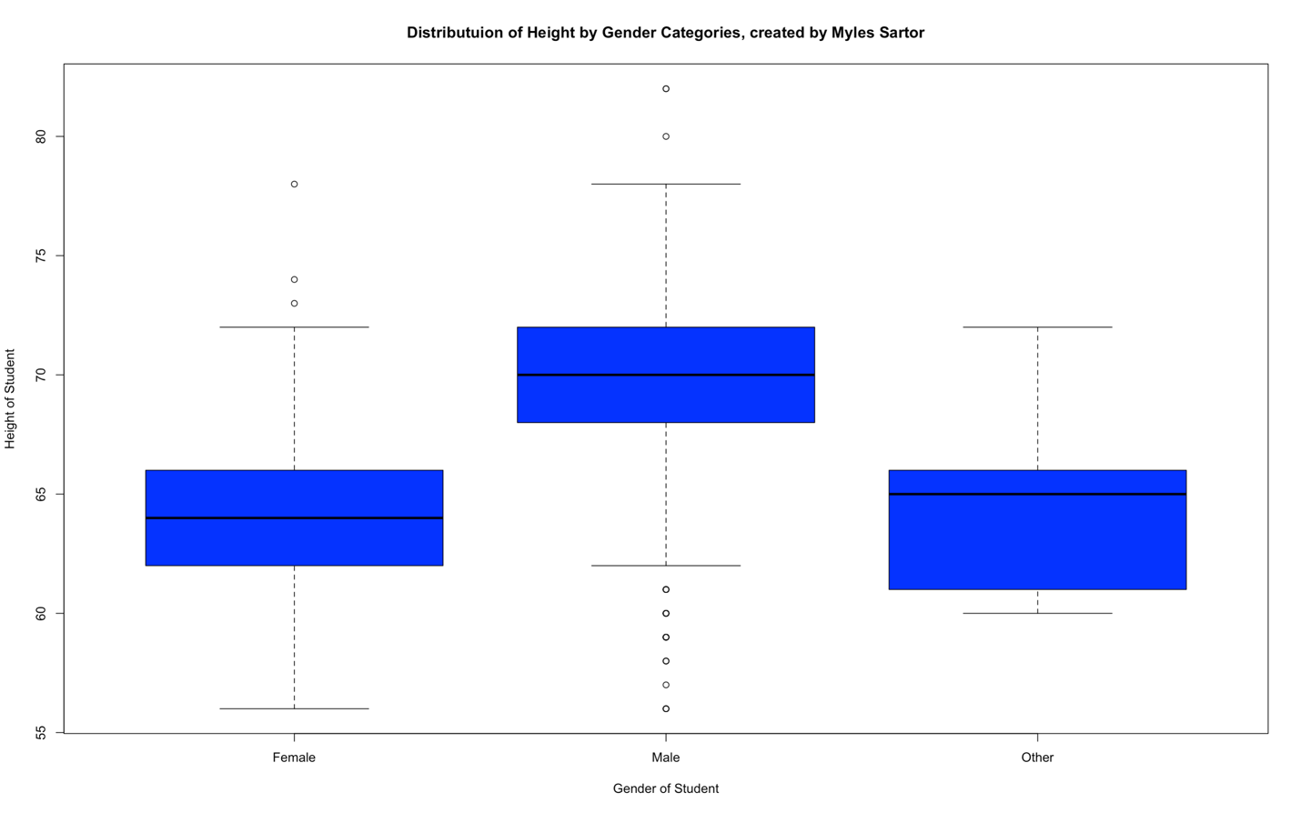
3b. Based on the boxplots, it appears as though the median height for the male students is 70, and the median height for the female students is 64. I found these values by looking at the line within the boxplots (Q2) that determines where the median lies for each of them. This middle line alone tells me where the median (middle value) is for the parts of the data set representing these specific gender categories.
4a. 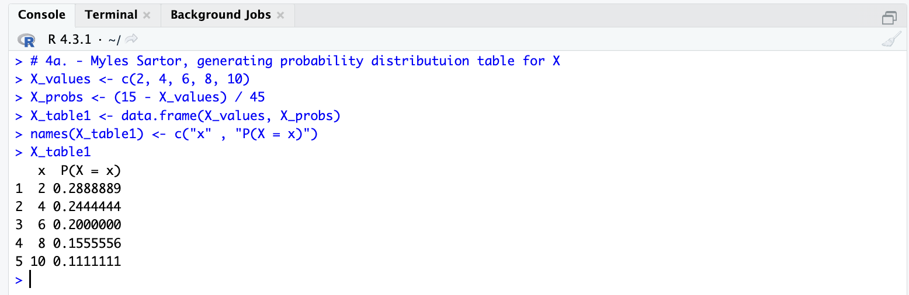
4b.
Mean of X (expected value of X) = 2 (0.2888889) + 4 (0.2444444) + 6 (0.2000000) + 8 (0.1555556) + 10 (0.1111111) = 5.111
Mean of X = 5.111
5a. 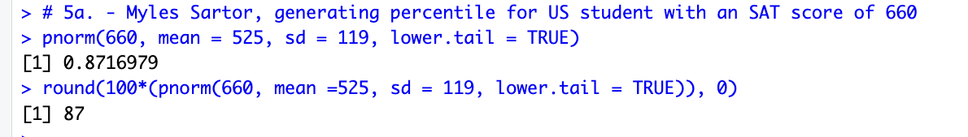
5b. 470 – 525 / 119 = -0.46 = z-score
P (z < -0.46) = 0.3228, same as saying P (x < 470).
0.3228 is the same as saying 32.28 %, meaning that an SAT score of 470 is in the 32nd percentile for all US students.

